**For More**

**Information, Contact**

**T.C.C. by email:** [**careerexpo2@gmail.com**](mailto:careerexpo2@gmail.com)

**or**

**251.275.3255**

**Much More Than A College Fair**

**More than 2400 students from local area schools will be attending!**

**Please register by visiting our website: tcccareerexpo.yolasite.com**

**\*Forms are available online**

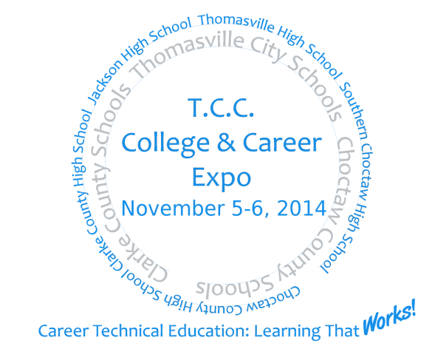



**Choctaw County**

**Chamber of Commerce**



**Jackson Chamber of Commerce**

**2014**

**EXPO**

**Grove Hill Chamber of Commerce**

**Thomasville Chamber of Commerce**

**and**

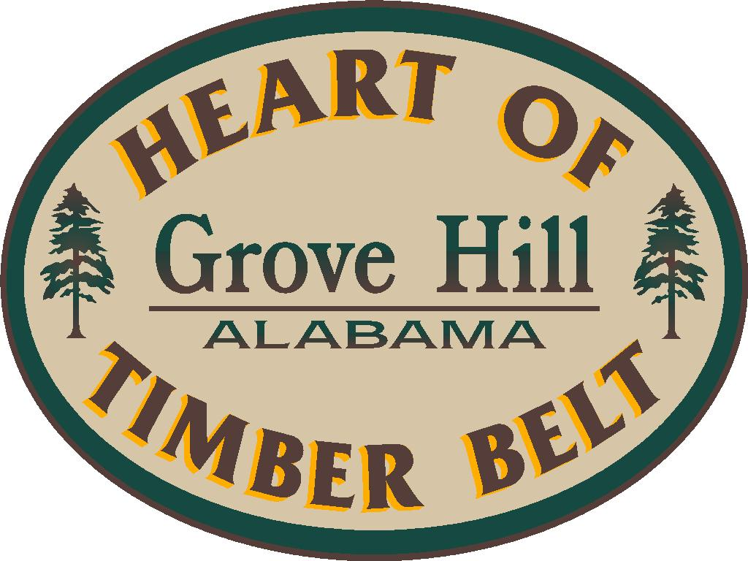

**Sponsored by the Thomasville, Clarke, and Choctaw County (T.C.C.) Career and Technical Education Programs**

**In Conjunction with Local Chambers**

**The Historic**

**Thomasville Civic Center**

560 West Front Street

Thomasville, AL 36784

Wednesday, Nov. 5, 2014

8:00 – 3:00 p.m.

Thursday, Nov. 6, 2014

8:00 – 12:00 p.m.

**Career**

**College**